**Department of Information Systems and Cyber Security University of Texas in San Antonio**



IS 3413: Telecom and Networking-001, Fall, 2022

Name: Daniel Cook  
UTSA ID: dhz799  
Email address: *danielwcook5@gmail.com*

Lab Assignment: Project Cisco  
Date Due: 11/21/2022  
Date Submitted: 11/21/2022

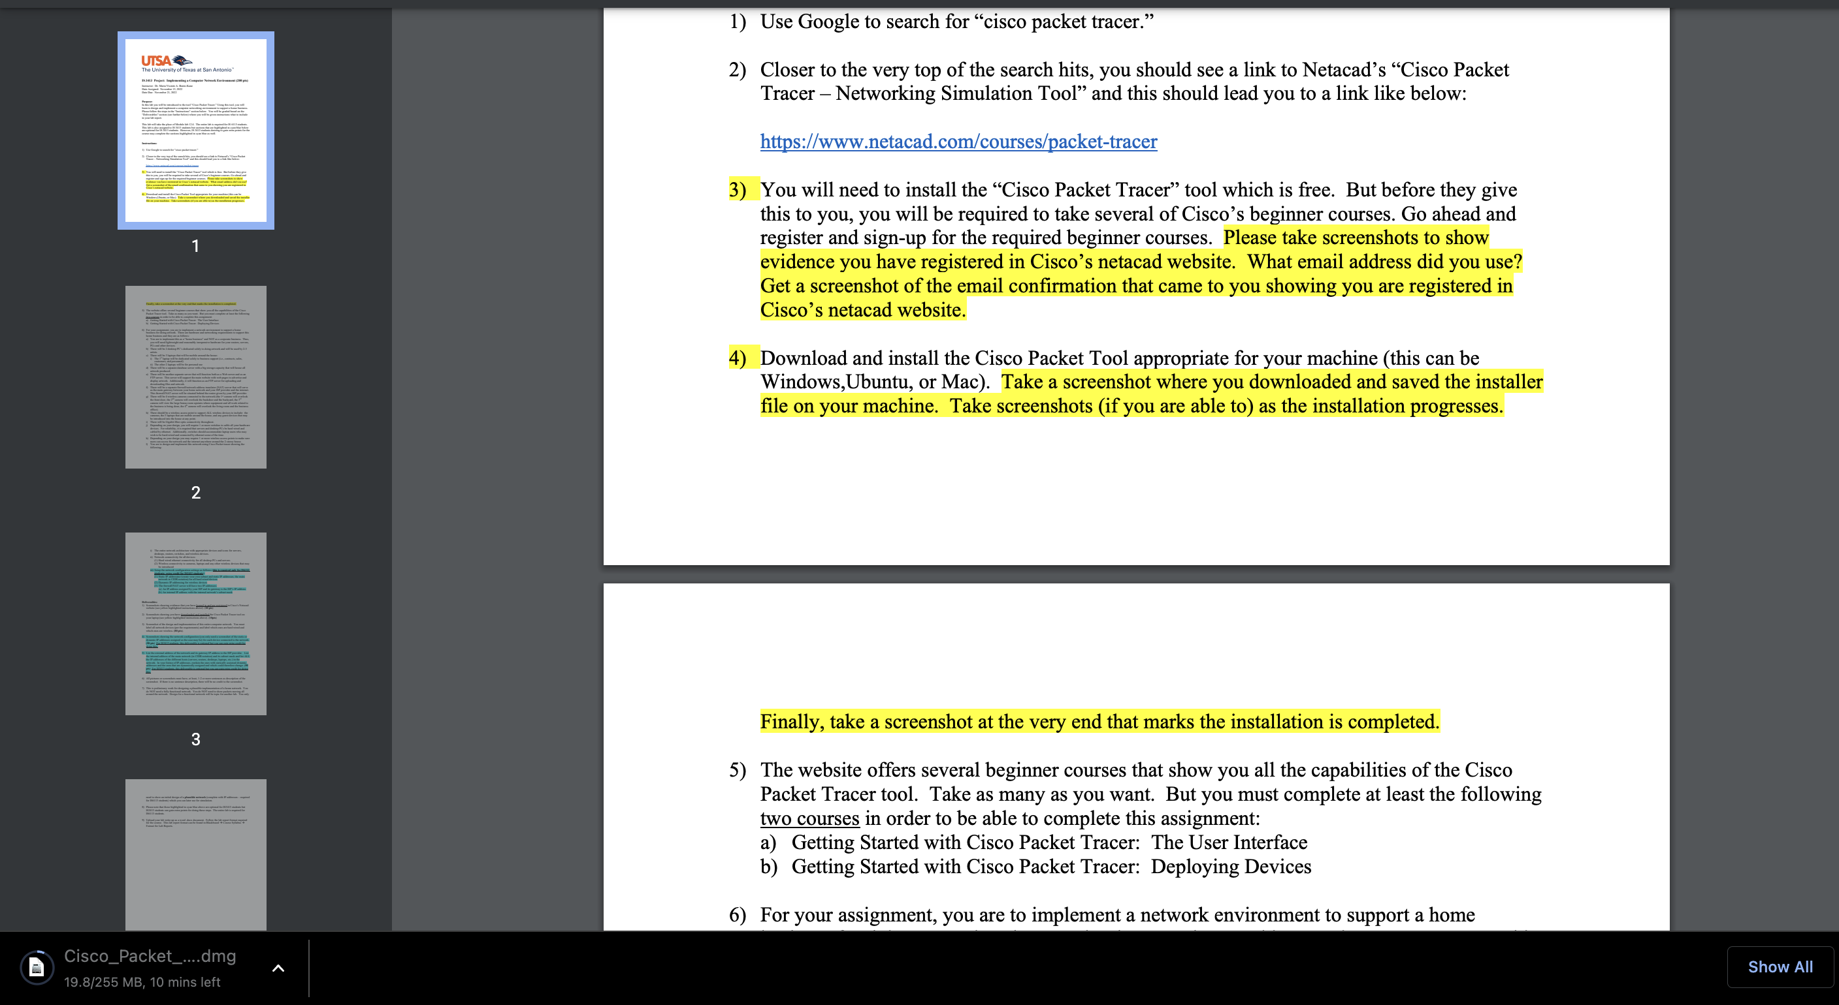

>Downloading Packet Tracer  
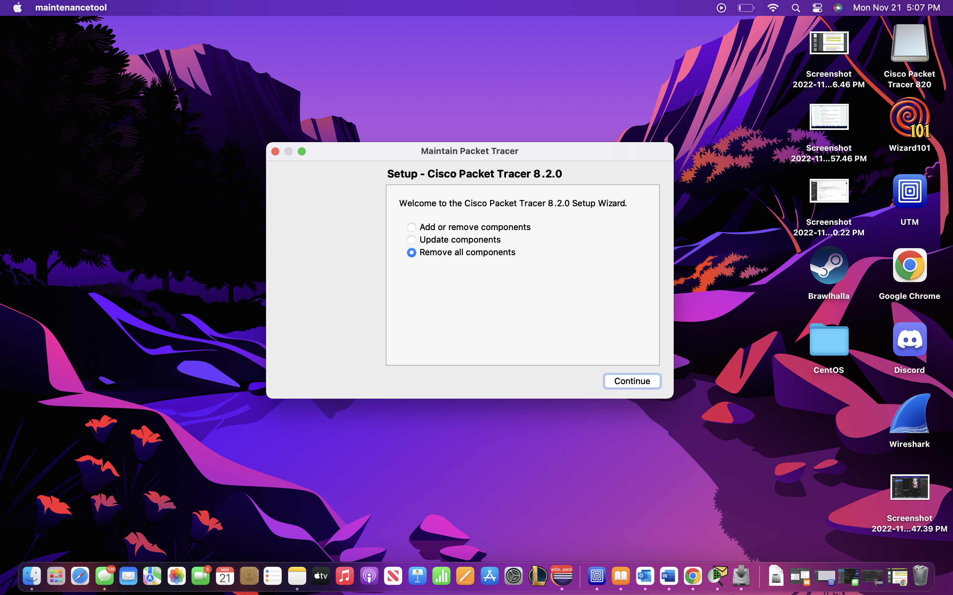

>Download Completed

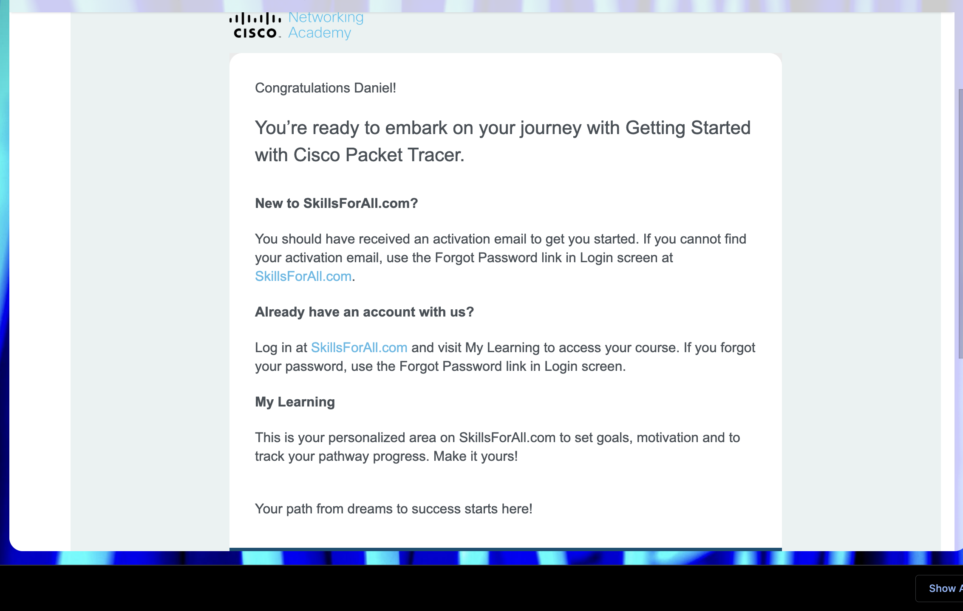

>Email received. I used my personal email.

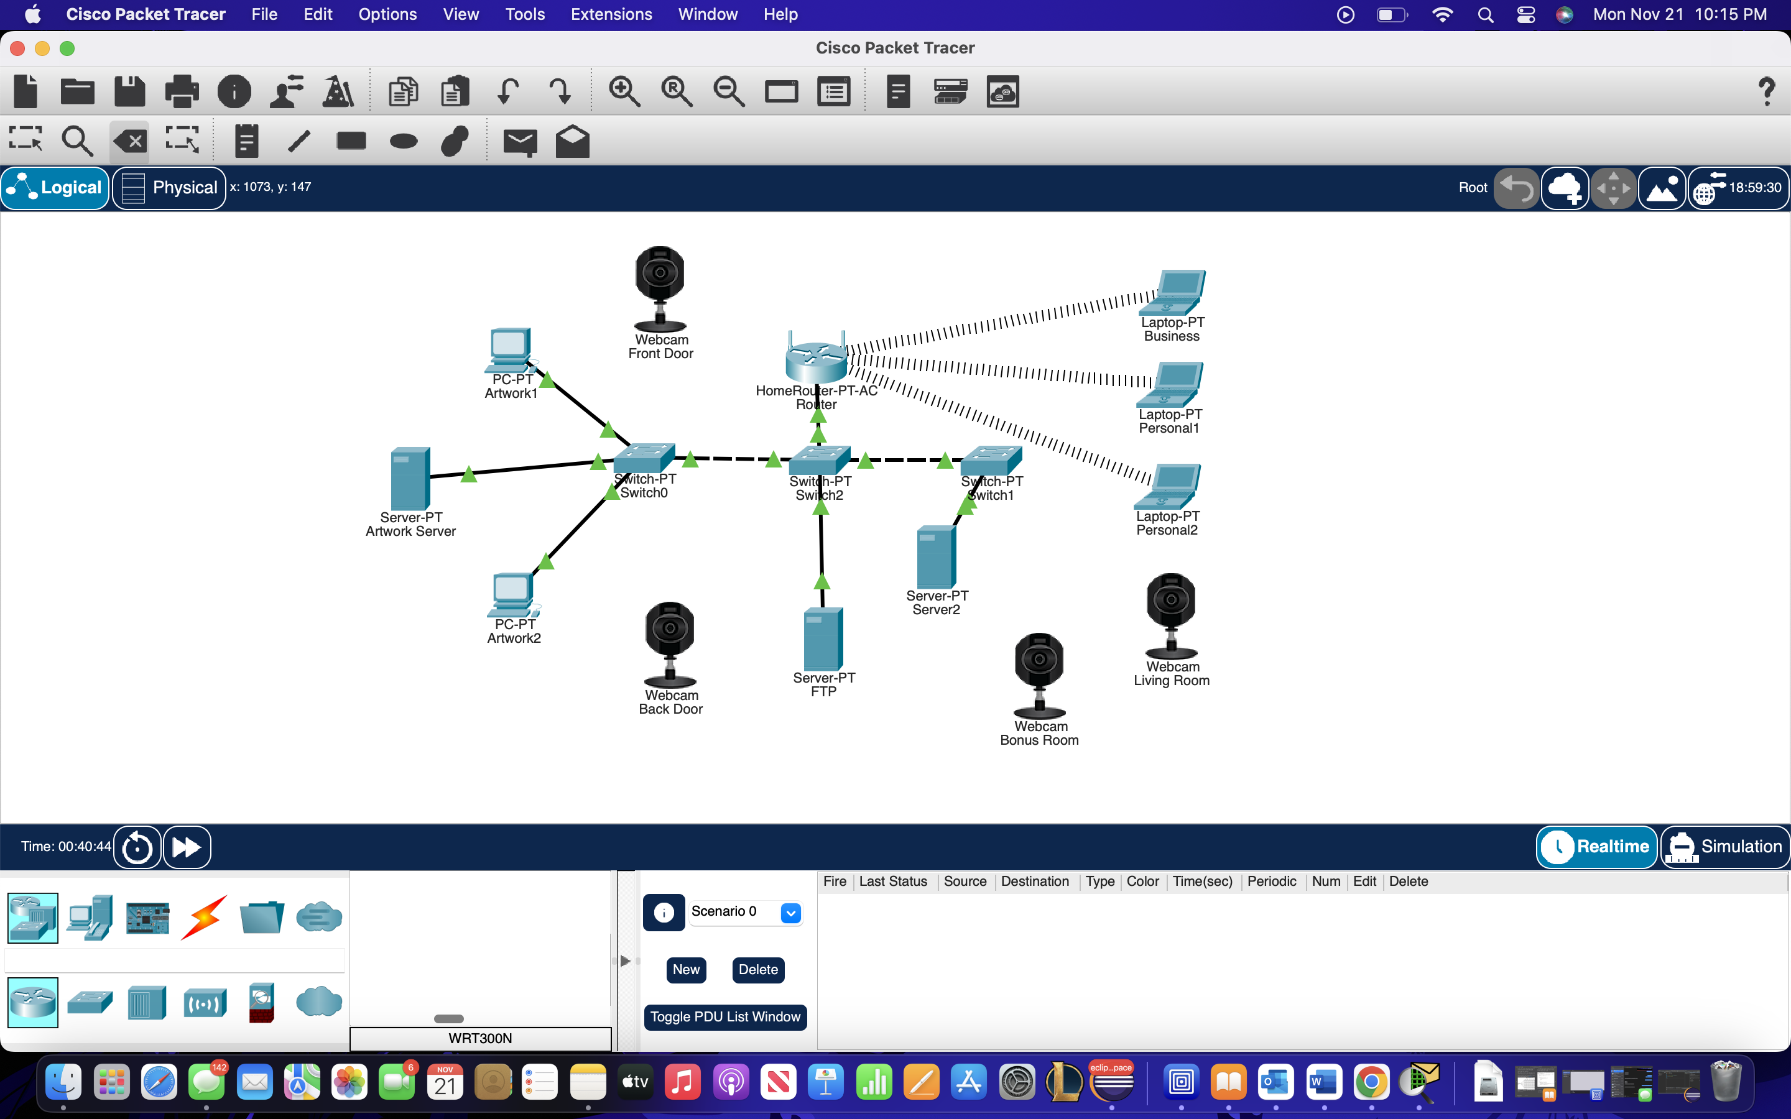

>Overview of the network

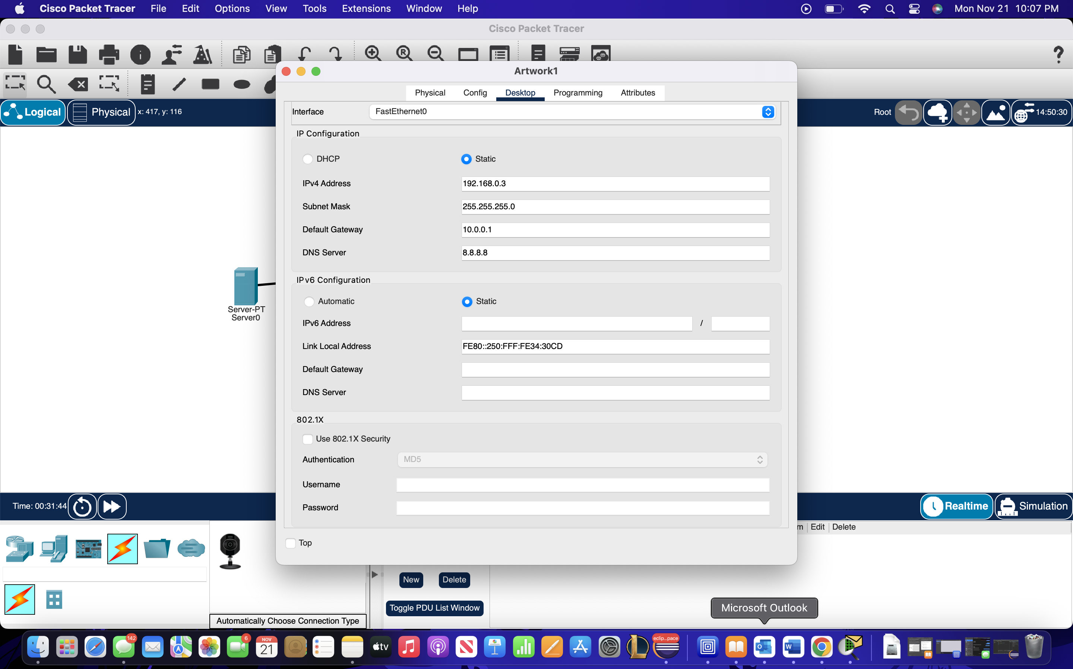

>Configuration for PCs with static IP

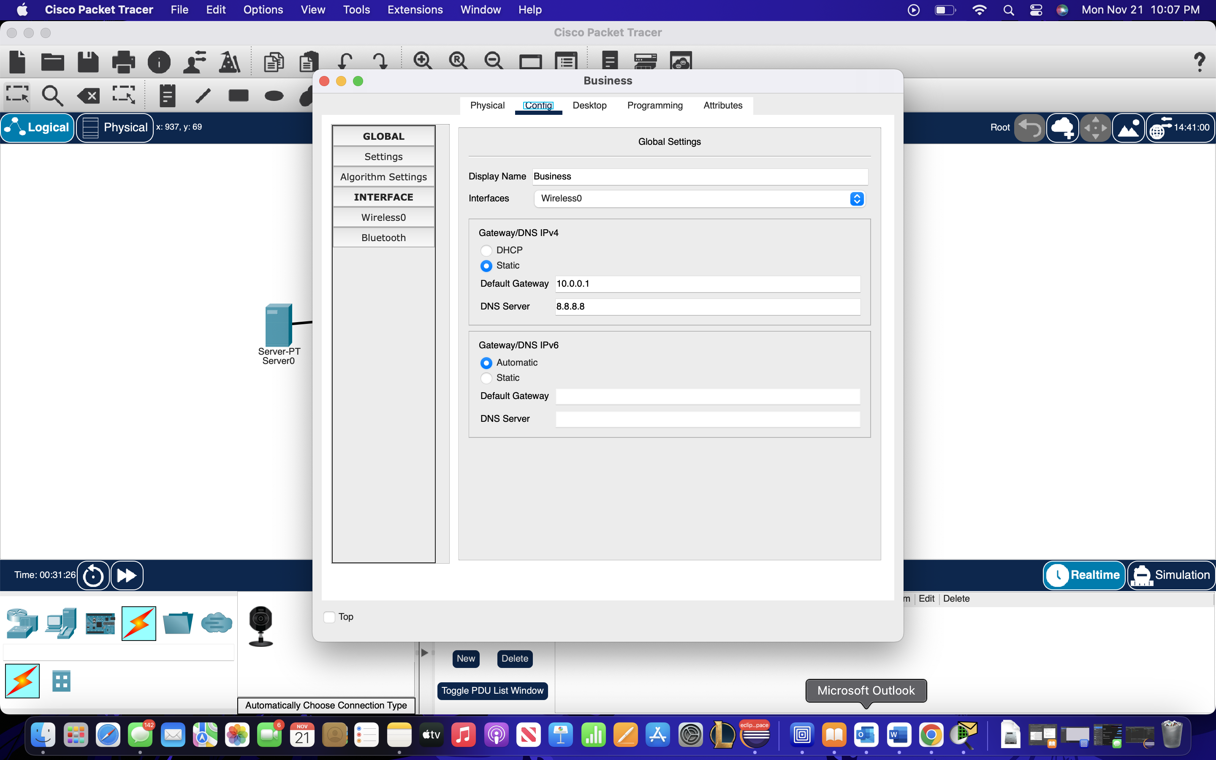

>Configuration for laptop with Dynamic IP